Unit 8
Introduction to Rules

Custom Fields (c_fields)

When writing a report, not all information needed for a report can be gathered using just standard fields. At times, custom fields need to be created in order to calculate a desired value. In Report Designer these custom fields are called c_fields.

A c_field can be created by adding a new field to the Fields Screen of a report. The naming convention for a c_field is c_ followed by a free text field name. The following screen capture displays a c_field example:

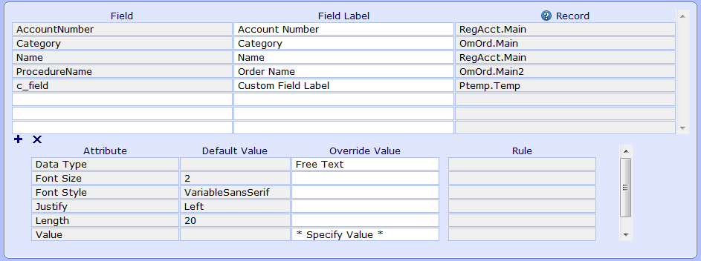
Once the c_field has been named a value must be defined for the field. The Value attribute can be defined by placing free text in the Override Value column or by assigning a rule to the c_field in the Rule column.

If free text is defined for the c_field, that field will print that literal value. If a rule is defined, then the c_field will output the value that rule calculates. A rule is where all logic will be done for a report. Rules are where IF statements, Do Loops, String Extraction, and all other calculations will be set up.

With Attribute:

As seen in the last screen capture, a Field Attribute of “With” defaults in for the c_field and is a required attribute. The With attribute defines the data record for the c_field as well as any rule created for that c_field. The field links defined for the chosen record will be passed to any rule created from that c_field.

Suppose we have a report written with a detail record of RegAcct.Main and also prints data from OmOrd. Below we can see a c_field with the text “The With Attribute is set to RegAcct.Main.”

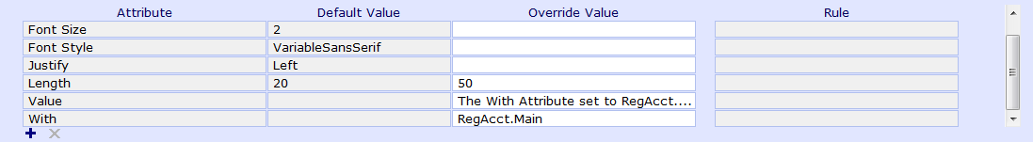
When we run this report, we can see the RegAcct.AccountNumber field printing once and the OmOrd.ProcedureName field printing several different orders. In the middle column, the c_field is printing only once, it literally prints with the other fields from RegAcct.Main.

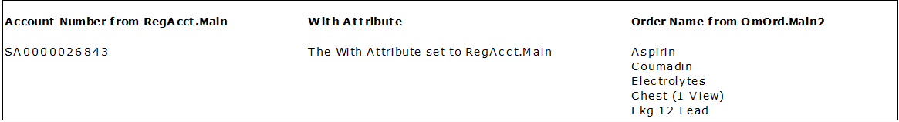
If we then take the same exact report, and change the c_field to use the OmOrd.Main2 record in the With attribute, we will see this same field printing in a different manner.

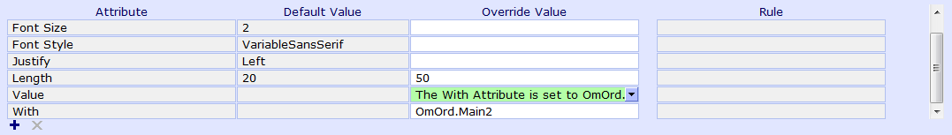
Notice that when the report now prints, the c_field executes once for each order attached to the patient. It literally prints with the other fields from OmOrd.Main2.

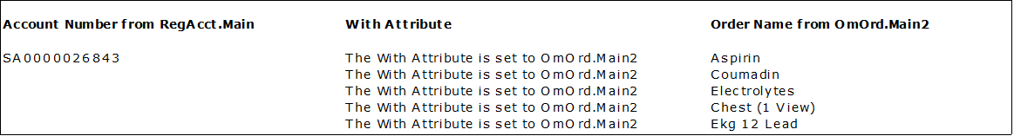

Note: if a patient has no orders on their account, then the c_field will not execute all.

By using the With Attribute, we are allowing the c_field to function as a field from the defined object. This allows the user to print text based on a basic condition as we can see above.

Rules Introduction

When writing reports, you may eventually want to format fields, create conditional statements, or access a field which cannot be linked to from the Fields tab. In these instances a Rule can be created to accomplish this.

The Rule Editor is a tool which is designed to allow the user to create custom logic without needing to have any prior knowledge of syntax or programing languages. It accomplishes this by having the user first define all data elements then entering the logic through a series of choices or “steps.”

To add a rule to a report, first create a c_field then delete the "*Specify Value*" text from the Override Value column and place your cursor in the Rules column of the Value attribute.

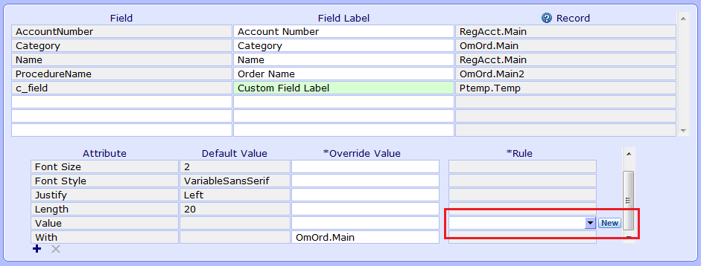

You can add an existing Rule to a c_field by typing the Rule mnemonic into the Rule column or by preforming a F9 lookup and selecting one from the available list. To create a new rule, click on the New button to the immediate right of the Value attribute.

Note: the New button is only available if the Rule column is empty. If a rule was previously added to the c_field, this button will instead read “Edit.”

Once pressing either New or Edit, the user will be taken the Rule Editor which is separated into three screens: Main, Fields, and Rule.

Main Screen:

The Main Screen of the Rule Editor is where the rule’s name and mnemonic are entered as well as any variables the rule will need.

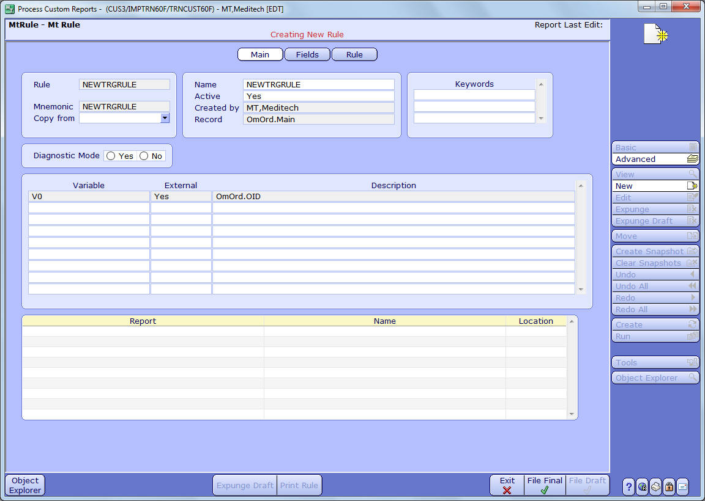
Mnemonic

Rules are stored separately from reports and therefore must have their own mnemonics. This allows the same logic to be used in many different reports.

If the mnemonic entered already exists, a warning message will appear instructing us to enter a different mnemonic. The mnemonic is free text and can be up to ten characters long.

Copy From

Just as with reports, the rule editor can copy existing rules. Simply choose a rule from the Copy From look up to import the logic into the new rule.

Active

This prompt defines a rule as active or inactive. Inactive rules cannot be added to c_fields.

Name

The Name prompt will default to the mnemonic of the rule but can be edited to provide the user with a more descriptive statement about what the rule accomplishes.

Created By

The user who originally created the Rule.

Record

When a new rule is created the With attribute of the c_field calling the rule defines the Record prompt.

Note: When adding an existing rule to a c_field you should match the record of the rule with the record set by the With attribute.

Keywords

Use the Rule Keyword Dictionary to create logical groups that identify similar rules. Assign keywords to the rule at this prompt.

Variables

Define all variables that will be used in the rule's logic. Variables should be free text and describe what will be stored within that variable. You must define at least one additional variable here since the output of the rule must be saved as a variable. The following is a screen shot of the Variables section of the Main Screen of a rule:

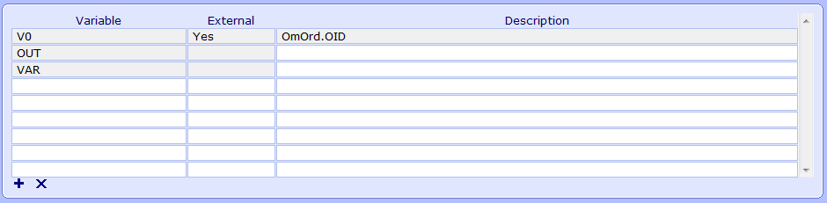
The keys of the rule's record, set by the WITH attribute, default in this section setup as V# external variables. These variables are considered external variables as they come from the report into the rule based on the record chosen. The first key of the record is stored as V0. If there are any more keys to the record they will be set as V1, V2, etc. This defines the keys of the record for the rule. Anytime a key needs to be used to access a field it will be represented by it's V# variable.

Note: Any variable that is not an external variable or an Evariable (see Unit 10) is local to the execution of the rule and is known as an internal variable. The values stored in these internal variables do not carry over to other rules or the next execution of the same rule.

Used on Reports

The bottom section of the Main screen contains additional information on the rule including what reports that rule has been used in.

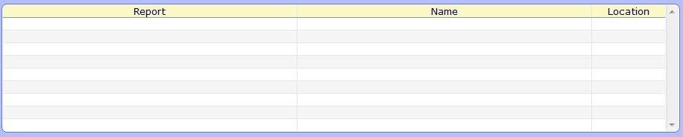
- Report - Displays the mnemonic of existing reports this rule is used within.
- Name - Displays the names of existing reports this rule is used within.
- Location - Displays the screens that this rule has been used on within existing reports.

Fields Screen:

The next screen of the rules editor is the Fields Screen where you will define the records, fields, or queries that you will use in the rule's logic.

Record/Index

Define any records or indexes that you will loop through in the rule's logic. This lookup provides a list of all Records and Indexes available in the entire system. After choosing a record or index, the keys of that record or index will appear in the keys section. At that point, variables or free text must be assigned to each key depending on the loop you are setting up. See Unit 21 on Do Loops for more information on how to set this up.

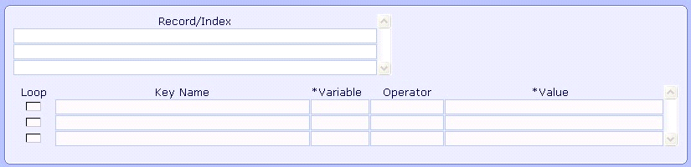

Fields

Define any fields that you will use in the rule's logic. The same field lookup that is available on the Fields page of the report is available here. After choosing a field, any keys needed in order to access that field will appear in the Key Name prompt. Any field from the rule's record will automatically have a value populated in the Value column. If a field needs additional keys to be defined, you will need to assign that key a variable or free text value. This is covered more in Unit 15 on subscripting.

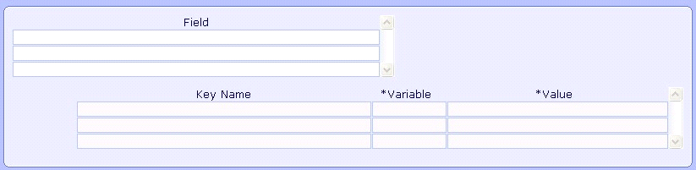

Queries

Define any queries that you will use in the rule's logic. A lookup to all available queries can be used here. After choosing a query, the keys needed to access that query will appear in the Key Name prompt. If a query needs additional keys to be defined you will need to assign that key a variable or a free text value. This is covered more in Unit 16 on Query Responses.

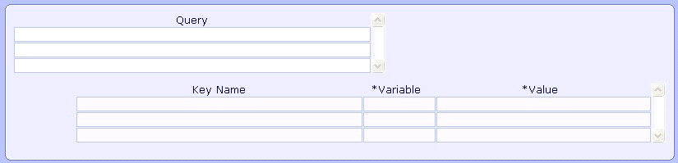

Rules Screen:

The final screen of the Rule Editor is the Rules screen where you will define the logic of your rule.

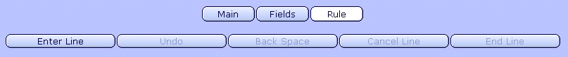

To create the logic of your rule, utilize the buttons at the top of the screen as well as the drop down menus that appear to step through a myriad of choices.

Click on the Enter Line button to begin creating the logic.

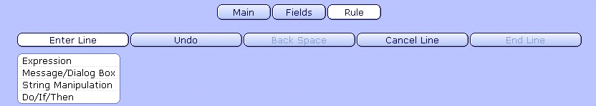

A drop down menu appears that will allow us to create logic and expressions from several choices. Each choice will bring us to additional menus with choices. As we continue to click on various buttons it will build the rule in step by step.

Expressions

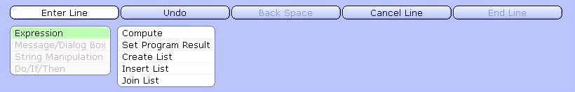

Click on Expressions in order to:

Compute - To create arithmetic calculations or save values as variables.

Set Program Result - To tell the system an end result to display.

Create List - To put variables or fields into a list, often needed when working with Rule Functions (see Unit 13).

Insert List - Will insert variables and fields at the beginning of an existing list.

Join List - Will add variables and fields to the end of a list.

When choosing Compute from the available expressions you will be able to reference fields, queries, variables, numbers, free text, and system variables in arithmetic statements and other expressions.

Compute is most often used when needing to store any value as a variable. This occurs often within If statements and Do loops which you will see in the coming units.

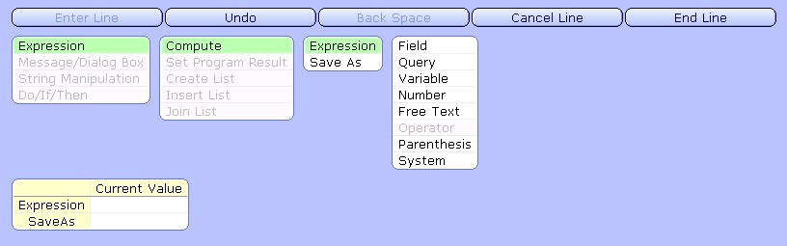

Message/Dialog Box

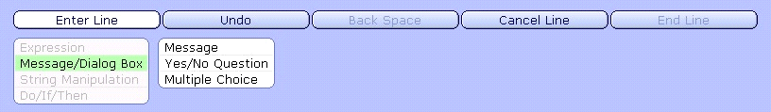

Click on Message/Dialog Box to:

Message- Create an FYI and Critical Messages.

Yes/No Question - Create a message to be displayed to the care provider requiring a Yes or No response. (Note: This action requires an additional query to display the selected response.)

Multiple Choice - Create a message to be displayed to the care provider requiring a selection from a predetermined list of choices. Only one response can be selected. (Note: This action requires an additional query to display the selected response.)

String Manipulation

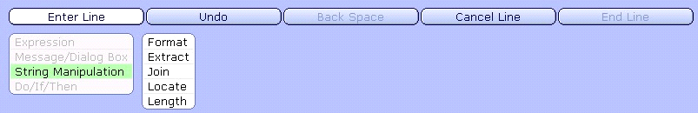

Click on String Manipulation to:

Format - Convert a variable or field to a different format or perform date and time calculations

Extract - String extracts a number of characters from a string

Join - Concatenates variables, fields, queries, numbers or free text into one string.

Locate - Finds a specific value within a string and returns the starting position if found

Length - Finds the number of characters of a string

Do/If/Then

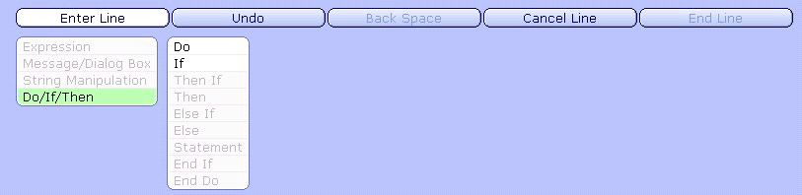

Click on Do/If/Then in order to:

Do - Create a Do loop on a record.

If - Create an IF Statement.

While the rule is being created there are two areas that will display what logic is currently being built and what logic has already been built. See the following screen capture:

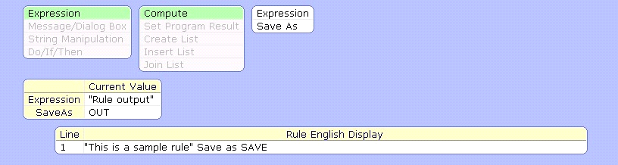

Current Value

The Current Value display will always appear when following any of the steps above.
Notice that the boxes in this prompt match the options to the right of the Compute choice above. The Current Value display can be thought of as an "in-progress" display containing the components of the current line that have already been entered.

The goal of entering logic with this system of steps is fill out this Current Value box. This will the be the case every time a line is entered.

Every line must end with the “Save as” prompt being defined with a variable from the Main tab. When ever a command is executed, the results of that command must sent to a variable.

Rule in English Display

Below the step entry buttons, all existing lines of the rule are spelled out as a readable version of the logic.

At the top of the screen there are four other buttons that will aid you in the creation of a rule:

Undo

Will undo the last action made in the rule.

Backspace

Will remove the last entered value.

Cancel Line

Will cancel the current line of the rule.

End Line

Click on this button to finish the input of the current line.

Finally, there are some additional buttons at the bottom of the Rule Screen that will allow the rule to be edited:

Edit

You can edit a rule during creation or after ending a line. Highlight the full line or single line you would like to edit and then click the Edit footer button. This will bring up a display box showing the Old Value and the Current value along with a couple of options. Highlight a specific part of the line in the Current Value box and use the Insert, Edit, Delete, and Append buttons to alter the logic of that line. The Current Value display will show the edited expression while the Old Value display will show the original expression. To apply the change to the rule, click the End Line button.

Insert

Use Insert to add a new line of logic above a highlighted line. This functions exactly the same way as the Enter Line button.

Move Up

Use Move Up to move a highlighted line of logic above the previous line.

Move Down

Use Move Down to move a highlighted line of logic below the subsequent line.

Remove

Use Remove in order to delete a highlighted line of logic from the rule.

Output of a Rule:

A rule can only directly output a single value. The output of a rule will always be the value of the last line of logic in the rule.

General Steps to Create a Rule:

Main Screen
1. Set up variables to be used in the Rule
2. Take note of the V# variables defined based on the Record of the Rule

Fields Screen
3. Define any records or indexes that will be looped on in the rule or fields or query responses that will be used in the rule.
4. For any record, field, or query added make sure the necessary keys are defined.

Rule Screen
5. Define the logic of the rule by clicking on the appropriate buttons and drop down menus.
6. File the rule

On Entry Rules:

So far we have learned mostly about rules being called from c_fields. Rules can also be called from either the General screen and/or the Regions screen utilizing the On Entry attribute. On Entry Rules provide a great place to perform logic and calculations separate from other functions, such as print conditions and custom fields.

The On Entry attribute allows for multiple rules to be called prior to when Indexes or the Selects being evaluated from the General Screen:

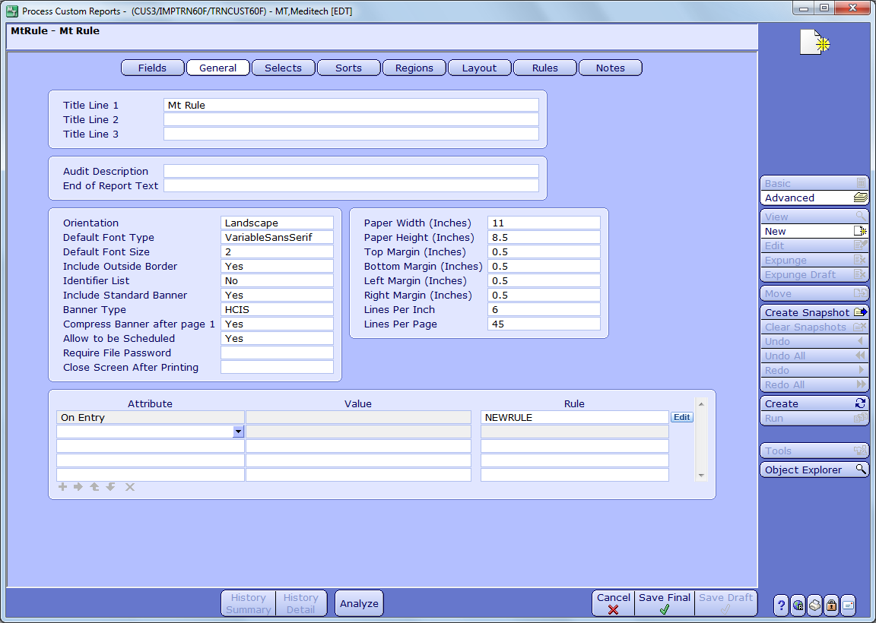
The On Entry attribute also allows for multiple rules to be called before a specified region is printed. Pictured next is the Attributes section. Using the On Entry Attribute, one or more rules can be added to perform their functions prior to the printing of the highlighted region. On Entry Rules can be added to any active region on the report.

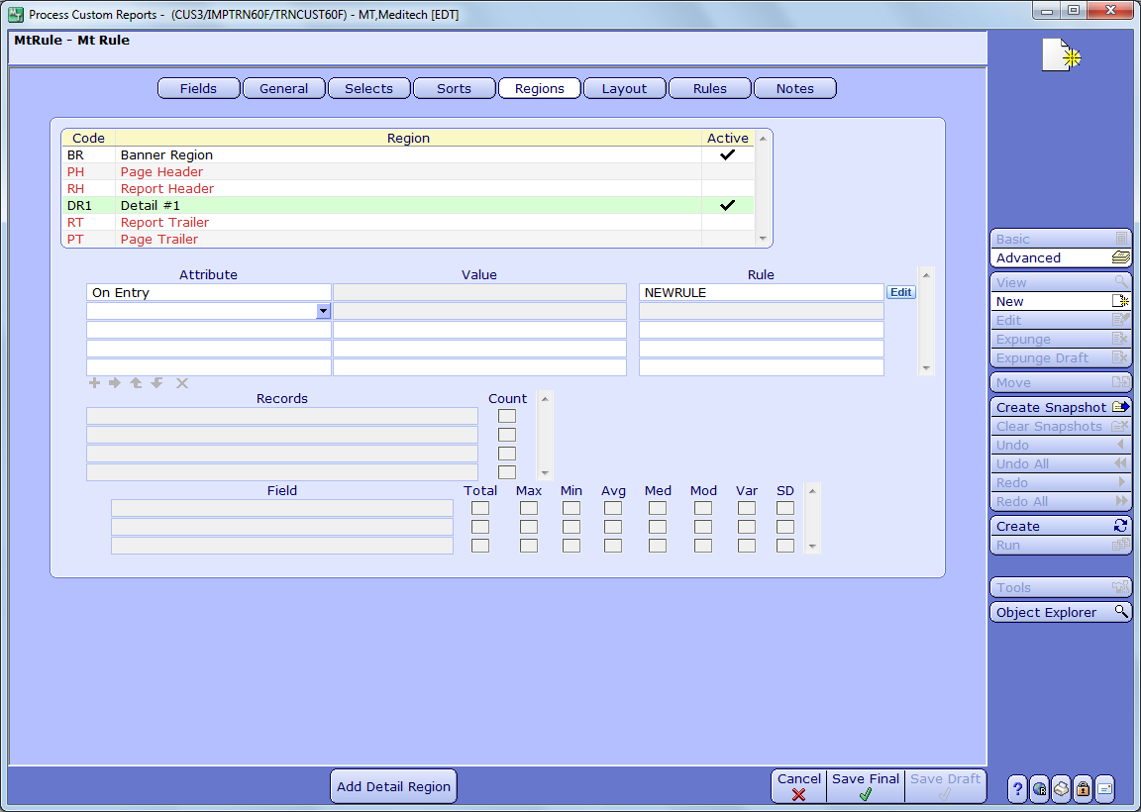
Once the cursor is pointed in the Rule column, the blue ‘New’ button or the blue ‘Edit’ button in can be used to create or edit an On Entry Rule. To create a new rule, point cursor under Rule column prompt click on the blue New button. To add an existing rule, either type the mnemonic of that rule directly or use an F9 lookup of all existing rules. If a rule is added under the Rule column prompt, it can be edited by then clicking on the blue ‘Edit’ button. When clicking on either the blue Edit or New buttons, users will be brought to the rule editor.

Report Designer Workshop - Unit 8 Introduction to Rules

Directive
Create a new report out of RegAcct.Main to output patient names and account numbers for a discharge service date range. Also, create a computed field utilizing a single rule that will output the patients age field.

The following steps have been broken down by page. You will need to follow these steps in creating the report.

Fields
- Click on the New button on the right hand side of the Report Designer tool
- Enter the Mnemonic of your new report
- Add the fields AccountNumber and Name from the RegAcct
- Create a custom field with the naming convention of c_fieldname
- You can enter an associated label if desired
- For the Value attribute associated to this field, highlight the *Specify Value* in the Override Value field and remove it
- Next, click in the Rule column, then click on the New button to create a new rule

Rule – Main
- Enter a mnemonic of the rule you wish to create
- Add a variable of OUT to the list of variables

Rule – Fields
- Proceed to the field section
- Add the field RegAcct.Age to this section. The required key for this field should default to V0

Rule – Rule
- Create logic to output the field Age in the variable of OUT
- You will need to build an expression to compute the field Age and Save As OUT
- File the rule after completing these steps

Selects
- Add the field of DischargeServiceDate as a select and use the In Range operator
- Add the Index of RegAcct.DischSvcX

Regions
Add a Page Header region to the report

Layout
- On the layout page use the AutoFormat Button to add all fields and labels to the report
- File the report using the Create button and then run the report to output the results

Unit Notes:

