Unit 9
If Statements

If Statements

If statements are control structures that allow you to define a specific output based on a condition. An If statement can be created from the Do/If/Then menu within the rule editor:

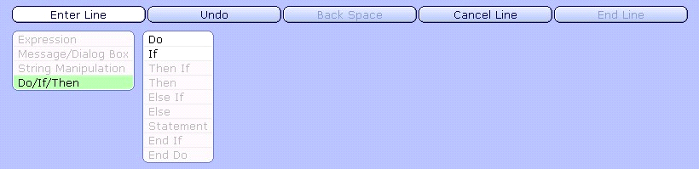

From the Do/If/Then option you can use:

Do - To loop though a record or an index (see Unit 21)

If - To evaluate whether certain criteria are met, and perform a function

Then - If to evaluate if additional criteria are met, and perform a function

Else (otherwise) - To perform a different function if a condition other than that expected for If or If Then is met

Statement - To perform some type of calculation

End If - To end an action when certain criteria are met

End Do - To conclude a loop (see Unit 21)

Choosing If will bring us to the following menu that will give us various choices to build our condition.

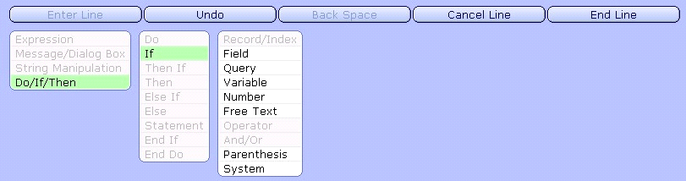

After the condition is made, statements can be set up to control what the output of the If expression will be. When the If statement is executed by the report, it will check the first condition. If that condition is true, it will output that conditions statement. If false, it will continue on to a second condition if one exists. If that condition is true, it will output that conditions statement. If there are no other conditions, the If statement will return nil.

Example: In a Order Entry report from the record OmOrd.Main, set up an If statement that will output the free text of “PROVIDER” if the order source is equal to "MD". Otherwise, output the free text of "OTHER". To do this a c_field with a rule will need to be created.

Prior to creating the rule to calculate the If statement, we will need to create a c_field to call the rule. Create a c_field called c_if. The With attribute should be set to OmOrd.Main. At the Value attribute delete the text from the Value column and place your cursor in the Rule column. Click on the blue New button.

Provide your rule with a mnemonic and name, for example SRCIF. On the Main Screen of the rule, establish variables to be used in the rule's logic. As stated previously you must have at least one additional variable added to this section in order to save the output of the rule. Set up as many variables as you need but note that you can always come back to this screen and add more if needed. For our If statement example, we will need only one internal variable:

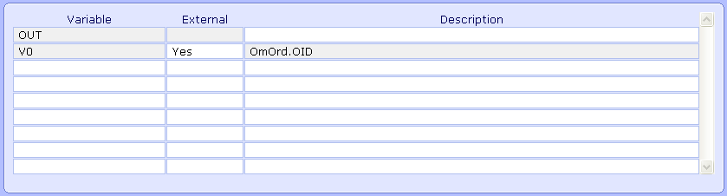

Note: As you can see in the above screen capture, the rules record is OmOrd.Main, corresponding to the With attribute. It defines OmOrd.Main's key of OmOrd.OID as variable V0.

Proceed to the Field Screen of the rule. Here we will set up any field, record, and/or query response that we need for the rule. For this example, we will be using the field OmOrd.Source. Go to the Fields section and do an F9 lookup. (Note: This is the same lookup that is on the Fields screen of the report) Go to the object OmOrd and add the Source field. Below the list of fields is a section that defines what keys are needed to have access to a field.

Note: If a field has its key(s) defined by the Record of the rule, those keys will default as the V# variables already set up.

In our example, the required key for the field OmOrd.Source is OmOrd.OID, this key should default to the variable V0.

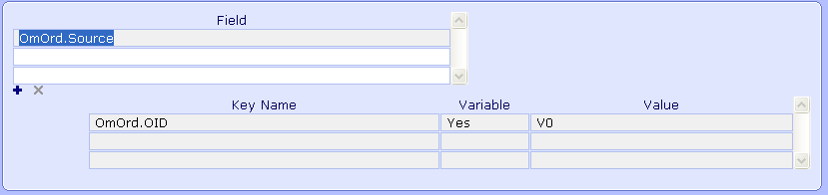

Finally, proceed to the Rule Screen where the actual logic of the rule is built. To create an If statement for our example we will follow these steps:

Enter Line > Do/If/Then > If > Field > Source > Operator > Is Equal To > Free Text > (type "MD" hit enter) > End Line
Then > Expressions > Compute > Expression > Free Text > (type "PROVIDER" hit enter) > Save As > OUT > End Line
Else > Expressions > Compute > Expression > Free Text > (type "OTHER" hit enter) > Save As > OUT > End Line
End If

Following those steps will create one line of logic in the rule which will execute the If statement and return "PROVIDER" if true and "OTHER" if false. The following is a screen shot of what the English Display of the rule looks like once complete:

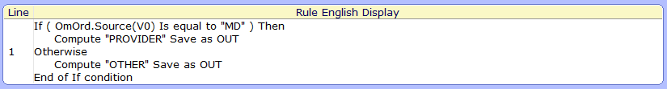
Once the rule is complete, click on the File button in the bottom right hand corner of the rule editor. This will file and translate the rule. The c_field that calls the rule can now be placed on the report's layout to be used to output it's value.

Report Designer Workshop – Unit 9 If Statements

Directive
Access the workshop report created in Unit 8. This report is written in REG and outputs patient data. You will start by creating a custom field on this report. This custom field will call a rule that utilizes an IF statement to output the free text of CHILD if the patient age is less than or equal to 18, otherwise output the free text of ADULT.

The following steps have been broken down by page. You will need to follow these steps in editing the report.

Fields
- Click on the Edit button on the right hand side of the Report Designer tool.
- Enter the mnemonic of your existing report.
- Create a computed field with the naming convention of c_fieldname
- You can enter an associated field label if desired
- For the Value attribute associated to this field, highlight the *Specify Value* in the Override Value field and remove it.
- Next click on the Rule field then click on the (blue) New button to create your rule.

Rule - Main
- Enter a mnemonic of the rule you wish to create
- Add a variable of OUT to the list of variables

Rule - Fields
- Proceed to the field section
- Add the field RegAcct.Age to this section. The required key for this field should default to V0

Rule - Rule
- This page is where we will be actually creating the Rule. The rule has to utilize an IF statement and check the patients age field. If it is less than or equal to 19, then output the free text of CHILD, otherwise output ADULT.
- File your Rule using the file footer button at the bottom of the Rule page. This will translate the rule into Object code.

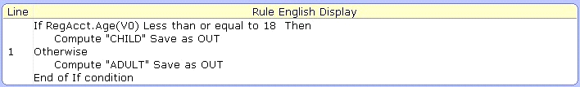

Layout
- On the layout page use the Auto Format button to add the new c_field and label to the report
- File the report using the Create button and then run the report to output the results

