Unit 11
Counting and Totaling

Basic Totals

The Regions screen of the Report Designer has prompts that allow for both record counts and totals to be set up. To get to these prompts, you will need to have a trailer region active and highlighted as shown in this illustration:

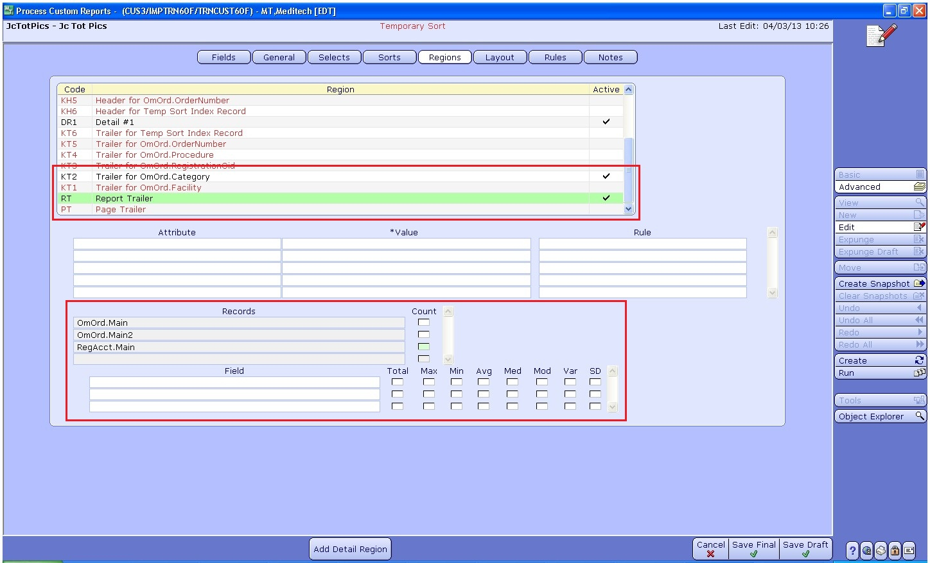
As you can see in the screen capture, having a trailer region highlighted allows you to
access the two bottom sections of this screen which is where you will set up record counts and totals.

Counting Records:
To create a record count first highlight an active trailer region, that you would like to add a record count to. For example, choose the Report Trailer, if you create a record count off a report trailer you will get a grand total of all instances of that record. Once the region is activated, the Records section at the bottom of the screen will have all records that you have on the report. To set up a count of the number of records within a record, check off the Count box for that record.

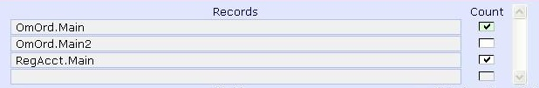
This will create a system generated total field called an m_field, which will contain the record count for that record. The m_field gets a system generated name based on the record it is counting and what region it is on. Once this field is checked off, it will show up in the Fields Section of the report. We have created a record count for both OmOrd.Main and RegAcct.Main so we will have two m_fields:

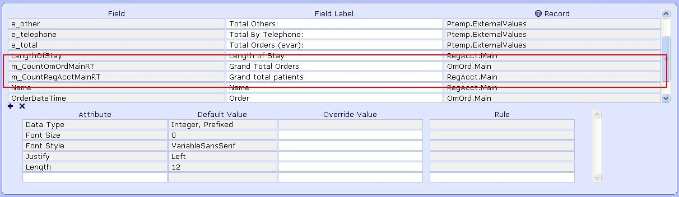
When the m_fields are printed they will print the total of all instances that pass the select criteria for that record. To print out the m_fields they should be Auto Formatted on to the Layout.

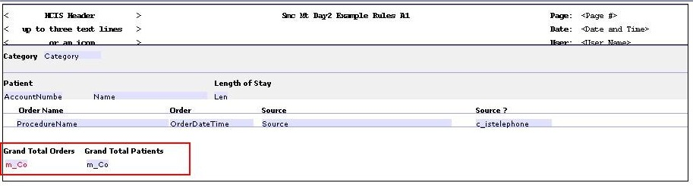
The m_fields should appear in the regions that they were created from. Here we have grand totals of all records from OmOrd.Main and RegAcct.Main printing at the end of this report, so a total of all orders and patients that passed selection.

The same process can be done when trying to create sub total record counts. You will just want to choose to do the count off of a trailer key region instead. Here are some screen captures that show that process. First, the report trailer key on the Category sort has been added and the record counts have been checked off:
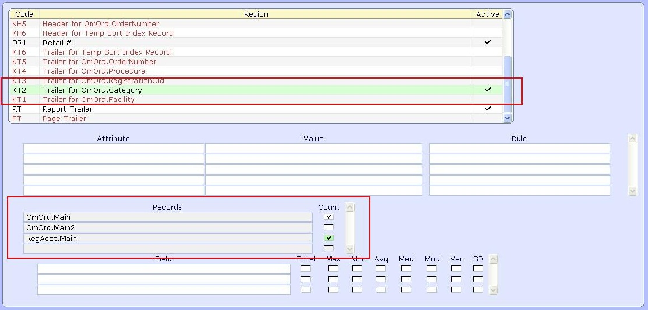
This created two m_fields that we can then auto format onto the report layout:

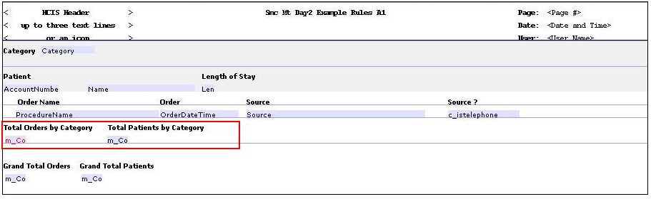
So now we have sub totals of patients per category, and orders per category. This will print for each different Category on the report.

Totaling Numeric Data Fields

Totals of numeric data fields can also be set up via the regions page. Highlight an active trailer region that you would like to add a total to. Then click on the Record that contains the field you want to total on from the records section. Then put your cursor in the Fields section at the bottom of the screen:

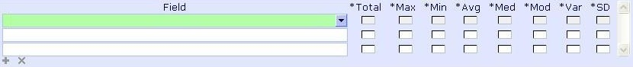
An F9 lookup is available here of all numeric data fields from that record:

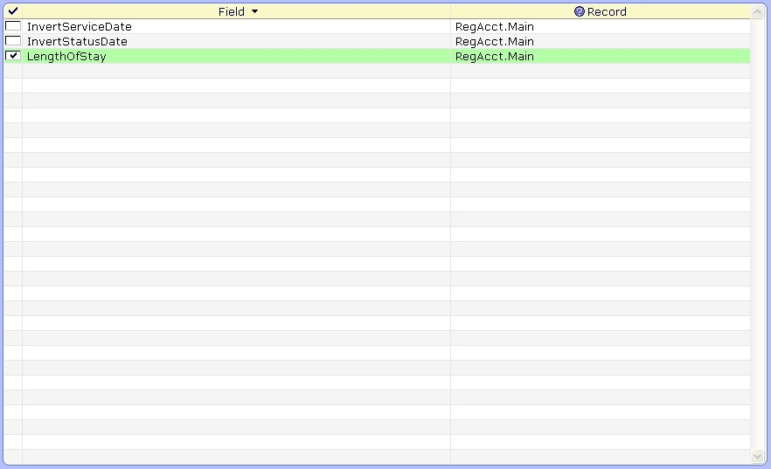
At this point, choose the data field that you would like to do a total on. Once you have selected a field, you will then be able to click off the calculation you would like to do with that field. Here we have selected LengthOfStay, so that field should appear in the total's field section:

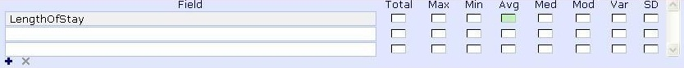
We can check off a number of functions to perform on the field:

- Total - Total
- Max - Maximum
- Min- Minimum
- Avg – Average
- Med – Median
- Mod – Mode
- Var – Variance
- SD – Standard Deviation

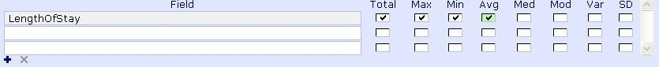
This will create an m_field for each one of these functions. Since this is being done on a Report Trailer these functions will work in the following way:
- Total – A Grand Total of LengthOfStay for all patients on the report
- Maximum – The highest LengthOfStay value from all patient on the report
- Minimum – The lowest LengthOfStay value from all patient on the report
- Average – The average of all LengthOfStay values on the report

These m_fields can then be Auto Formatted on to the Layout in the region they were created off of:

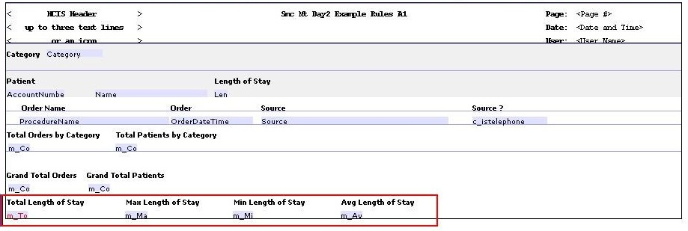
The same process can be done to create sub totals of numeric date fields. On a Trailer key, you can add a field to the field section, and then check off the functions that you want to perform on the field:

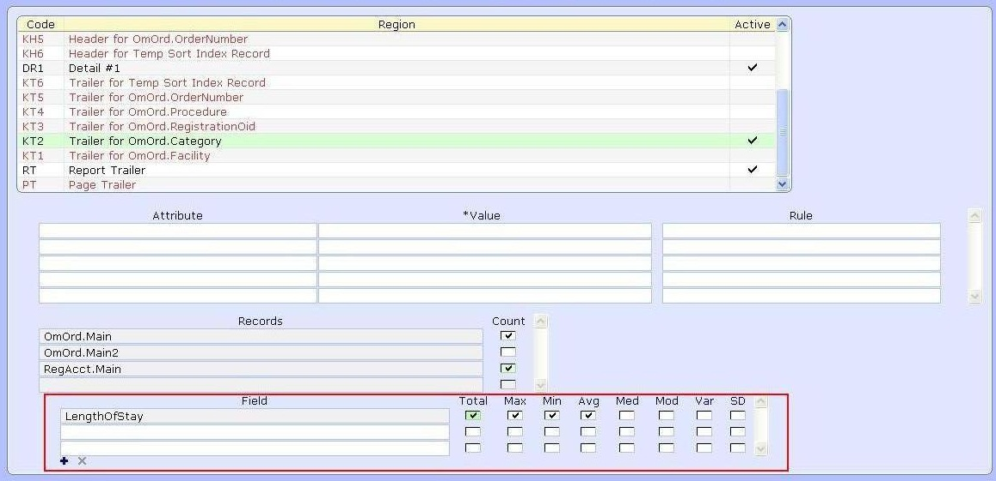
This creates four additional m_fields that will be Auto Formatted on to layout in the key trailer region.

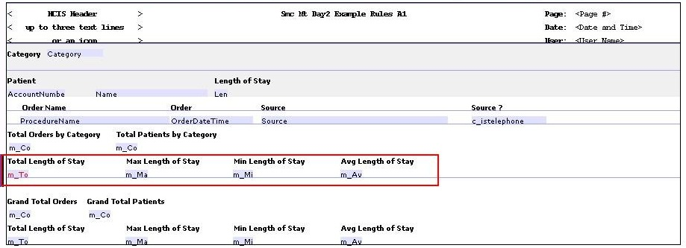
So this will get the same type of calculations as the ones on the report trailer, but would be per the sort value of Category.

Report Designer Workshop – Unit 11 Counting and Totaling

Directive
Edit your workshop report from Unit 10 to include the total number of patients assigned to each Location as well as a grand total of all patients on the report. Also, edit the report to create some conditional totals in Evariables from an On Entry Rule. These Evariables will capture the total number of adult patients and child patients for the report.

The following steps have been broken down by page. You will need to follow these steps in editing your report

Part 1:

Fields
- In your workshop report add the field Location

Sorts
- Add Location as the first sort of the report

Regions
- Check the KT1 Trailer Region for RegAcct.Location, then check the Count box for this region associated with RegAcct.Main
- Check the RT Report Trailer region, then check the Count box for this region associated with the RegAcct.Main record as well
- Check off a KH1 Header Region for Location as well

Layout
- Use Auto Format to add the Location field and m_fields to the layout. You can change the labels of these fields once added.
- Drag the Location field and label to the KH1 region

Part 2:

Regions
- Proceed first to the Regions and highlight the detail region
- Add the On Entry region attribute, and click on New to create a new rule
- On the Main screen set up the following variables: e_adult and e_child
- On the Fields screen of the rule add the field of RegAcct.Age
- The rules logic on the Rule screen should be an If statement that incrments a count in e_adult if the patient's age is over 18. The e_child variable should be incremented if the age is 18 or under. (See Picture)

(continued on next page)
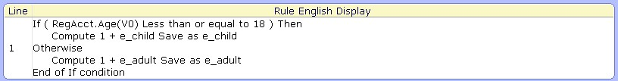
Fields
- After filing your On Entry Rule proceed to the Fields screen and do an F9 lookup to add a new field
- In the lookup click on the Externals button to display available Evariables
- Check off the e_adult and e_child Evariables and click Ok.
- These Evariables should now be fields in the Fields section and you can add labels to them or change attributes for them

Layout
- Auto Format these Evariables on to the layout. Drag them down to the Report Trailer region along with their labels. Create and Run the report.

