Unit 12
System/State Variables

System/State Variables

In Report Designer, we have the ability to use System and State variables in rules or to print as fields. The following is a list of available System and State variables:

- Country
- Facility Access
- Facility Menu
- Facility Name
- HCIS
- Him Dept Access
- Him Dept Menu
- Language
- Ring
- Signon User
- Universe
- Universe HCIS
- Bus Unit Menu (6.1+ only)
- Client
- Client Type
- Emulated User
- Process Controlled By
- Signon User Mnemonic
- Signon User Name
- User Mnemonic
- User Name
- Report Start Date
- Report Start Time
- Report Title
- Report Start Date Time
- Report Name
- Key Page Number
- Report Page Number
- Now
- Today
- Today.Now

System and State variables can be used in the following section of Report Designer:

- Fields
- Selection
- Rules

Fields:

System variables can be printed on report by adding them as fields. To do this do a field lookup on the Fields screen of the report. Within the lookup there is a footer button labeled System Variables, click on this button.

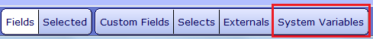
This lookup displays a list of all available System variables that can be used as fields:

Here, you can check off which variables you would like to use as Fields on the report. The selected System or State variables will appear as v_fields in the Fields section:

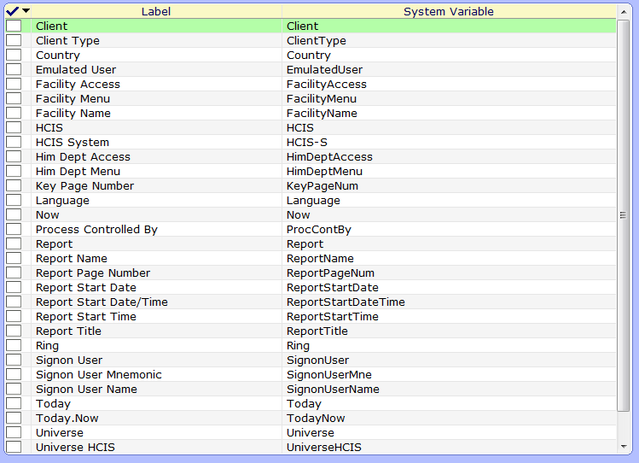
Here we would check off all System Variables that we would want to print, and then click on the Ok button.

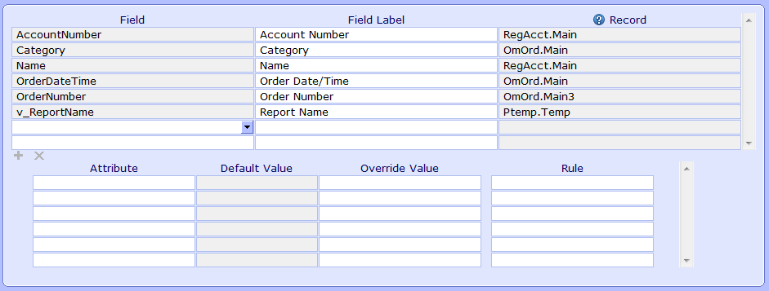
The System Variable will then appear in the fields list. System variables are prefixed with a v_ which is then followed by the name of the system variable. The System variable can then be printed on the layout like any other field.

Selection:

Within a report's selections, a new Attribute called System Variable exists. This attribute allows the user to identify a System or State variable at the Value field for this Attribute. Here we have a select on OmOrd.Facility. We are looking to set this select up with the facility of the user running the report.

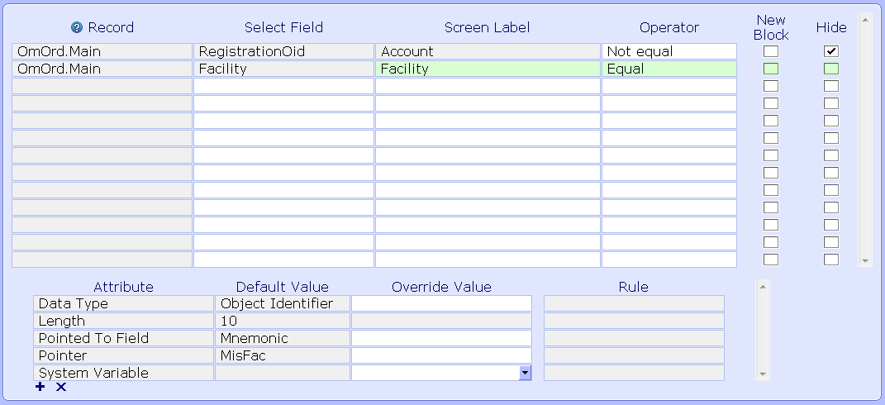
So the facility select is added and the System Variable select attribute is added. A lookup is available here with all available System Variables:

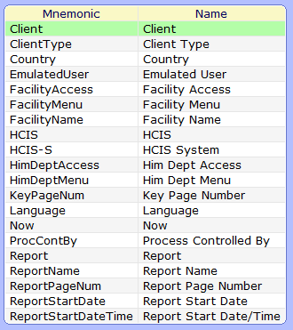
The FacilityMenu should be picked for this example. That contains the Facility of the user running the report.

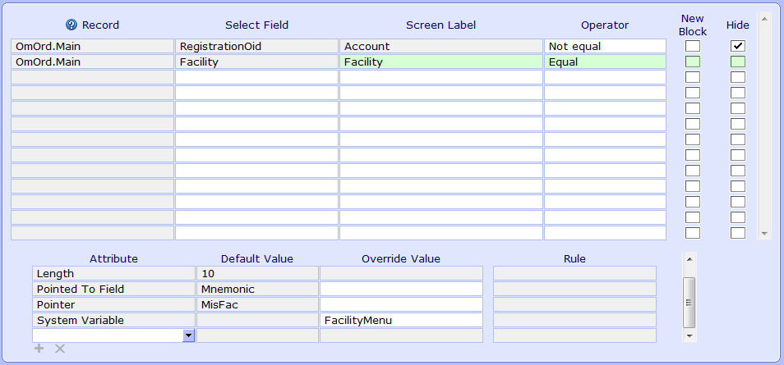

When a System or State variable is added here, the select will run for the value of that System or State variable. If the user chooses a System Variable whose data type is different than that of the Select Field, the following message is displayed:

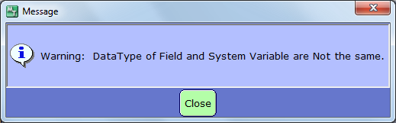
This is an informational message only, and the value will be accepted.

The System Variable select value can be used in two different ways:
- Default – leave the set up the way it is seen above. This will default the value from the system variable for the select when run. It can be changed when run, or run for the facility that defaults
- Hardcode – check off the hide box. This will hardcode the value of the facility of the user for the facility select.

Rules:

System Variables can also be used in rules. When entering a Line for a Rule, a new choice has been added called System. When System is clicked, the list of System and State variables displays on the screen.

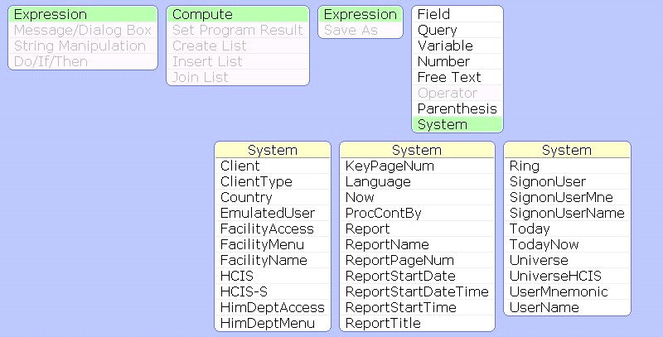

In Rules, the v_ prefix is not added to these fields, they just appear with the System Variable mnemonic. We will see an example using a System Variable in a rule in Unit 13 on Rule Functions.

Report Designer Workshop – Unit 12 System/State Variables

Directive
Edit your report from Unit 11 so that the report only selects patients that are entered into the facility that the user has logged into when signing into Meditech.

The following steps have been broken down by page. You will need to follow these steps in editing your report.

Fields
- Select the edit button to edit your existing report
- At the report field you can perform a lookup to edit your report

Selects
- Add the field Facility as an Equals select. For this select add the attribute of System Variable and set that to FacilityMenu. Check off the Hide Box for this select as well.
- Click on the Create Button
- Once the report has translated click the Run Button and print your results to View

